

OBJECT ORIENTED PROGRAMMING
LAB PRACTICAL FILE

(B.Tech CSE 2023-27)

Submitted By: Submitted To:
Name-Anjali Soni
Batch No: 4

EXPERIMENT – 1
TITLE: Introduction to Java Environment
1. Explore and understand the role of JDK, JRE and JVM.
Answer:
- JDK (Java Development Kit): The JDK is a software development kit that provides the tools needed to develop Java applications. It includes the JRE (Java Runtime Environment), a compiler (javac), a debugger (jdb), and other tools.
- JRE (Java Runtime Environment): The JRE provides the necessary environment to execute Java applications. It includes the JVM (Java Virtual Machine) and the Java class libraries.
- JVM (Java Virtual Machine): The JVM is responsible for executing Java bytecode. It acts as an intermediary between the Java code and the underlying operating system. The JVM makes Java platform-independent because the same Java code can run on any system with a JVM.

2. Install the latest available JDK and verify the Java Environment.
Answer:
- Download JDK: Go to the official Oracle website or a trusted OpenJDK distribution (e.g., Adoptium) and download the latest JDK version for your operating system.
- Install JDK: Run the installer and follow the instructions. Usually, you'll choose the installation directory and accept the license agreement.

- Set Environment Variables (if necessary):
  - JAVA_HOME: Set this variable to the JDK installation directory (e.g., C:\Program Files\Java\jdk-your_version).
  - PATH: Add %JAVA_HOME%\bin to your PATH variable. This allows you to run Java commands from the command prompt.
- Verify Installation: Open a command prompt and type java -version. If the JDK is installed correctly, you'll see information about the Java version.

3. Create a Sample Hello World Program using a simple text editor (e.g., Notepad) and show the steps to compile and execute the program using the command prompt.
Answer:
Create Java File: Open Notepad (or another text editor) and type the following code:
Save the File: Save the file as HelloWorld.java (make sure to choose "All Files" as the save type to prevent it from being saved as a .txt file).

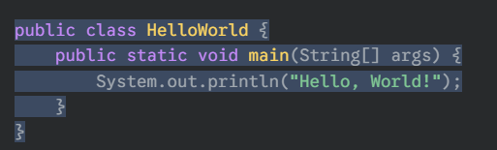
Compile the Code: Open a command prompt, navigate to the directory where you saved the file, and type the following command:
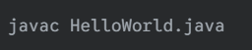
Execute the Code: If the compilation is successful, a HelloWorld.class file will be created in the same directory. Now, run the following command:
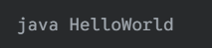
Output: You should see "Hello, World!" printed on the console.

4. Display your name and complete address in different lines.
Answer:
(Note: Replace the example information with your actual name and address.)
- Create Java File: Create a new Java file (e.g., MyInfo.java) or modify the HelloWorld.java file.
- Write the Code:
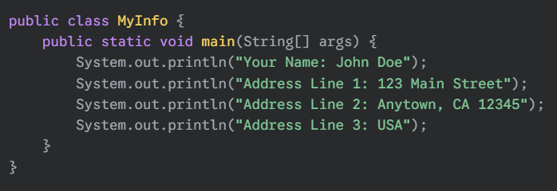
Compile and Execute: Follow the same compilation and execution steps as in the "Hello World" example.
Output: The program will print your name and address on different lines.

